COMPOSITES Ref: 009.1.16

PRODUCT DATA SHEET

BEARER BAR GRATE HD 800-80S

Description:
CIC grating is manufactured with continuous glass fibre strands and is an impact resistant, non conductive, slip resistant and easy to lay grating system. The Grating consists of three pultruded profiles. The Bearer Bar (thick) profile, the Guide Rod, and the Locking Rods. (See page three for the 3 part system).

Typical Uses:
- Flooring.
- Platforms.
- Walkways.
- Assembly Lines.
- Trench Covers.
- Stairs.
- Catwalks.
- Storm Drains.
- Government Offices.
- Military Installations
- Airport Perimeter.

Features & Benefits.
- A steel replacement product.
- Distributes loads for greater tensile strength to bi-directional bars.
- Manufactured from glass reinforced plastic.
- 100% corrosion resistant.
- Maintenance Free.
- Provided in UV Resistant colours.
- Allows repeated deflection on impact without permanent deformation.
- High abrasive / High chemical resistance.
- Integral silica grit provides slip resistance and protection.
- 25% of the weight of steel grating.
- Easy assembly and installation without the use of industrial equipment.

Recommended Application.
- Agricultural, Brewing, and Drinks Industries.
- Caustic, Chlorine, and Chemical Industries.
- Dairy, Food, and Fisheries Industries.
- Oil, Gas, Power and petrochemical industries..
- Paint, Paper, Water, and sewage treatment industries.

BEARER BAR GRATE HD 800-80S

Performance Data.
Fire Retardant. Class 1 Rating per ASTM E – 84.
Abrasive Resistance. High.
Cleaning. Normal detergent
Chemical Resistance. Will resist attack from most acids, alkalis oils, caustic solutions, sea water, grease etc.
Load Factor. 90kN / m2
Deflection. 1.91mm.
Dimensions. 800mm x 600mm
Depth. 80mm.
Area. 0.48 m2.
Weight.. 67.75gs / m2.

Manufacturers Standards:
- BE EN ISO 14122-3:2001.
- BS 6399-1:1996.
- BS 4592-0:2006.
- Products manufactured to client’s own design.

Bearer Bar Grate HD 800-64 manufactured to client’s specification.

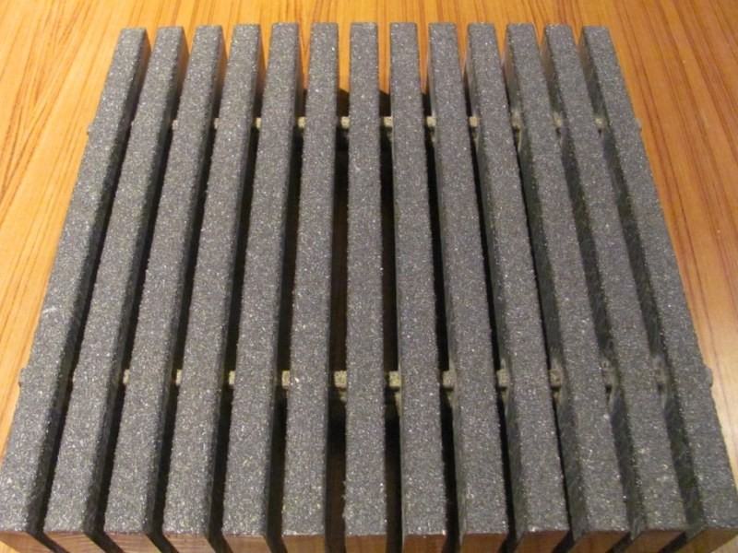

Tel: +234 80 601 80786
Email: sales@cic-wa.com Page.2.

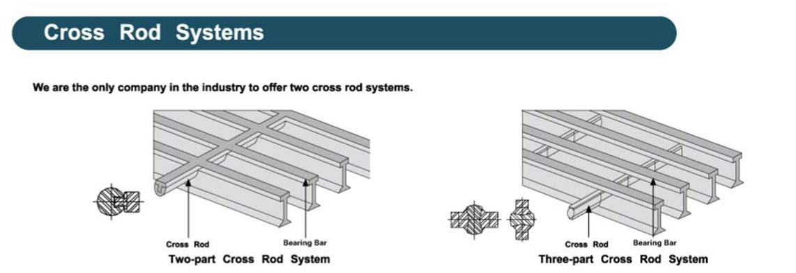

Page.3.

