COMPOSITES Ref: 010.1.16

PRODUCT DATA SHEET

PANDARAIL 1551-36-2

Description:
This Glass Reinforced Plastic handrail system complete with GRP moulded grating is designed for surface mounting only. The profiles are produced with the pultrusion process in ISO polyester resin using a grey pigment as standard. Other pigments available on request.

Typical Uses:
- Offshore and Marine.
- Petrochemical and refinery.
- Electrical and Power.
- Communications Generation.
- Water / Wastewaterl.
- Transportation and Transit.
- Automotive.
- Shipping.
- Government Offices.
- Military Installations
- Airport Operations.
- Mining.

Features & Benefits.
- A steel replacement product.
- Equal lateral load capacity to steel.
- Manufactured from glass reinforced plastic.
- 100% corrosion resistant.
- Maintenance Free.
- UV Resistant.
- Special U shaped hand rail for safety.
- High abrasive resistance.
- High chemical resistance.
- Light weight.
- Assembled using stainless steel rivets.

Recommended Application.
- It is recommended to use this Hand Rail as follows.
- Occasional Access and General Duty.
- Lateral Load capacity – 0.36kn/m.
Maximum stanchion span – 1600mm c/c.See separate Data Sheet for Installation.

PANDA RAIL 1551-36-2

Performance Data.
Fire Retardant. Class 1 Rating per ASTM E – 84.
Abrasive Resistance. High.
Cleaning. Normal detergent
Chemical Resistance. Will resist attack from most acids, alkalis oils, caustic solutions, sea water, grease etc.
Lateral Load Factor. 0.36kn/m.
Force. 360kg. acceleration / meter / second2.
Max. Stanchion Span. 1600mm.
Vertical Knee Rail Free Space. n/a.
Optional Kick Plate. 150mmx5mmx3mm.
Permitted Usage. Occasional Access & General Duty.

Manufacturers Standards:
- BE EN ISO 14122-3:2001.
- BS 6399-1:1996.
- BS 4592-0:2006.
- Products manufactured to client’s own design.

PandaRail Products manufactured to client’s specification.

PandaRail is a rich collection of today’s popular and proven handrail systems that can meet all your requirements, from small platforms to complicated structures. PandaRail has the capability to design, manufacture, and fabricate a custom system to meet your special need. For less complicated handrail projects, PandaRail can provide modular kits for cost-saving installations.

Page 2.
PandaRail Fiberglass Handrail A System - Split Tube Connector
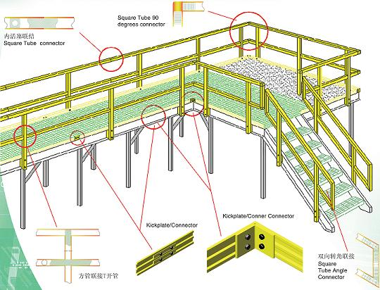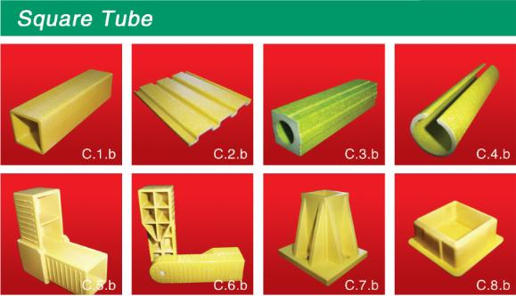

Page 3.
Minimum Mechanical Properties for Puitruded Rail and Post
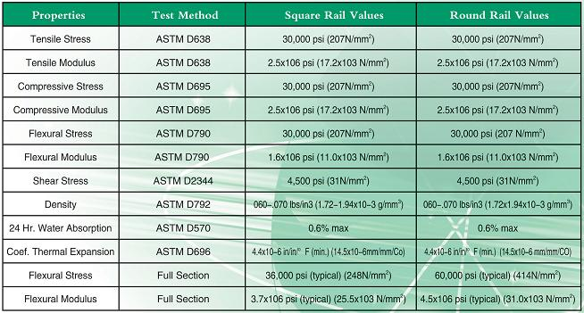

Corrosion Resistance
PandaRail™ system eliminates rusting and corrosion problem that always associated with traditional materials such as steel or wood, and provide a durable and safe structure that outlast metal or wood, yet offers a much lower life cycle cost.
Durable Pultruded Components
PandaRail™ handrail systems are designed and manufactured by a pultruder with more than 20 years of experience in the industry. The proven pultrusion process results in quality components that are long-lasting, corrosion-resistant and high strength-to-weight ratio.
Ease of Assembly
The PandaRail™ systems posts and rails are all produced in lightweight standard sections. All Systems can be prefabricated in large sections and shipped to site or they can be fabricated and installed on site with simple carpenter tools, thus eliminate heavy equipment and expensive tools, save on shipping cost and manpower.
Internal and External Connection System
All connections fit flush, resulting in a pleasing, streamlined appearance. The internal connections allow the construction of continuous handrail systems around circular tanks without any other special fittings.
Safety Features
The PandaRail™ systems feature low electrical conductivity for workers safety and exhibit a very high strength to weight ratio. All Systems meet the federal OSHA standards with a 2:1 factor of safety with 6-foot maximum post spacing. The PandaRail™ handrail systems also comply with the international standard AFNOR NF E 85-101.
Page 4.
Low Maintenance and Durable
Corrosion resistant fiberglass with melded-in colour will outlast aluminium, wood, or steel systems, with virtually no maintenance needed. All our handrail systems get their strength from a high percentage of glass roving and mats within the laminate, providing durability, high unidirectional strength and stiffness.
Cost Effective
Fiberglas components and easy-to-assemble design provides a saving on labours and maintenances, which will result in long-term savings and elimination of the cost and inconvenience of repairing in plant operations.

EXAMPLES

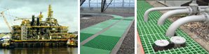

Tel: +234 80 601 80786
Email: sales@cic-wa.com Page.5.

